**Configuration of High Availability**

**TAC and Job server.**

Approval

| Signatures by each signatory indicate their acceptance that this document is complete and accurate to the best of his/her knowledge per responsibilities outlined in this document and as guided by approved methodologies and established procedures. | | |
| --- | --- | --- |
| Team Lead:  Artha Emp | **Subhransu** | **Date:** |
| Project Manager:  Artha Emp | **Pavan Valluri** | **Date:** |
| Talend Developer:  Artha Emp | **Omkar Patil** | **Date:** |

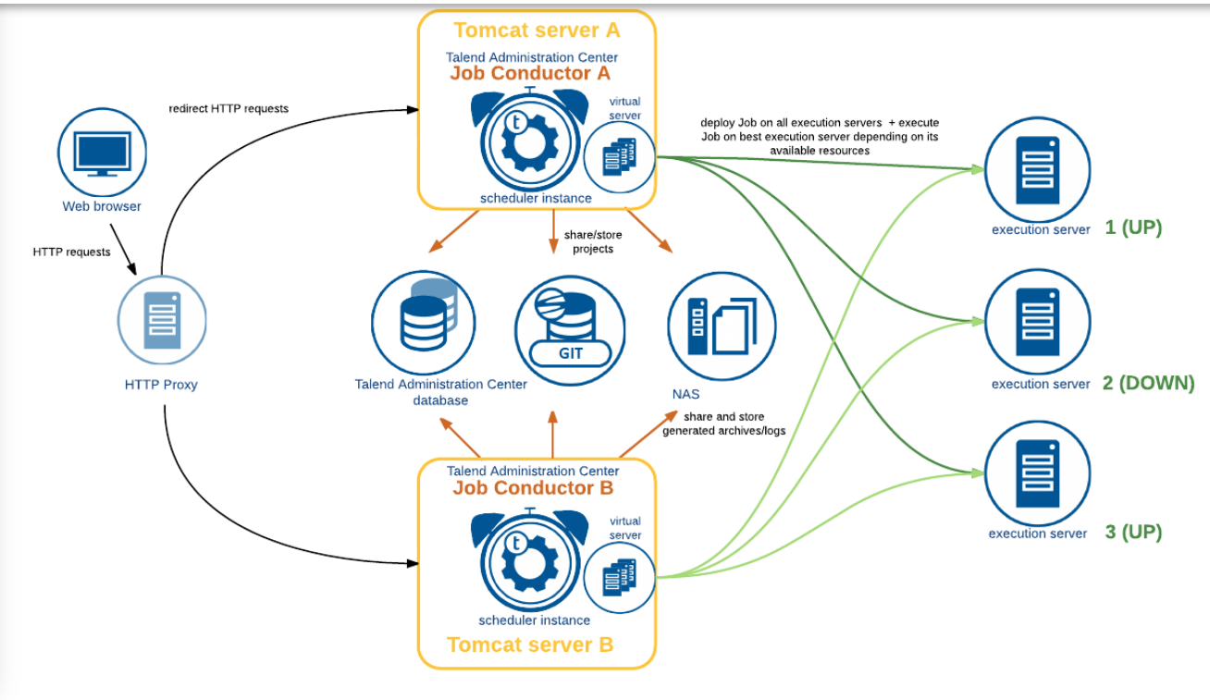

*Info of TAC High Availablity

<https://help.talend.com/r/en-US/8.0/installation-guide-linux/talend-high-availability>

*configuring virtual servers.

<https://help.talend.com/r/en-US/8.0/administration-center-user-guide/accessing-list-of-virtual-servers>

*For configuring the high the High Availability for Two TAC servers.

1. We need common nfs shared drive path of logs files.
2. We need common git connection for both TAC configurations.
3. We need same database configuration for both TAC.
4. We need to add the job servers on virtual servers in TAC.

*High Availability for Job server

We have to install the 2 different job servers on both server and need to configure in virtual servers in TAC servers.

# Use case:

If one of the job server fails job will run parallel on another job server.

*High Availability for TAC server.

We have to install the 2 TAC servers on the two different servers. and configure the both servers job server in both TAC virtual server’s configuration.

#Use case:

It will be work as a Active Active configuration. If we run a job on one TAC parally it will be run on the another TAC.

We need to configure Same configurations for both the TAC. If one of the TAC server fails, we can recover the jobs from another TAC server.

Step 1: - configuring nfs share drive Log files path for both TAC servers.

*We need the credentials of two job servers.

Ex: - we have 192.168.1.179( server 1)

192.168.1.47 ( server 2)

*We have installed the TAC and Job server on both Servers

*We have created the log file path on 192.168.1.179 ( server 1) mounting the same logs file paths to 192.168.1.47 ( server 2).

*Login to the 192.168.1.179 ( server 1)

Create paths in server and apply in Audit, Job Conductor and Logs section in TAC Configuration

#Audit - /srv/fileshare/Talend/Audit/reports

#Job Conductor - /srv/fileshare/Talend/Administrator/generatedJobs #Job Conductor - /srv/fileshare/Talend/Administrator/executionLogs #Logs - /srv/fileshare/Talend/Administrator/executionLogs/technicalLog/technical.log

#Logs - /srv/fileshare/Talend/Administrator/executionLogs/businessLog/business.log

#Install and start the nfs using the command

yum install nfs-utils

systemctl start nfs-server.service

systemctl enable nfs-server.service

systemctl status nfs-server.service

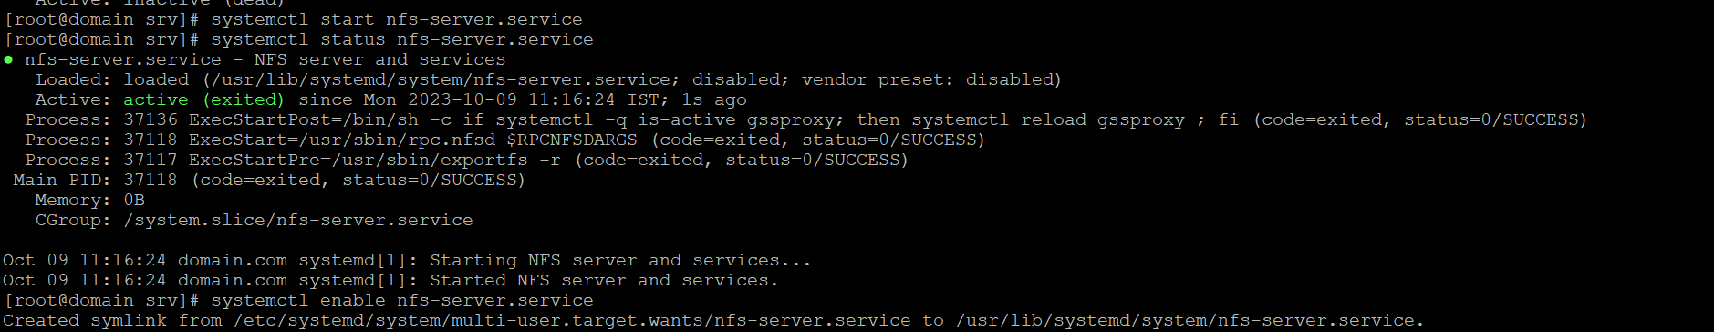

Cd /

chmod –R 777 /srv

cd /et c

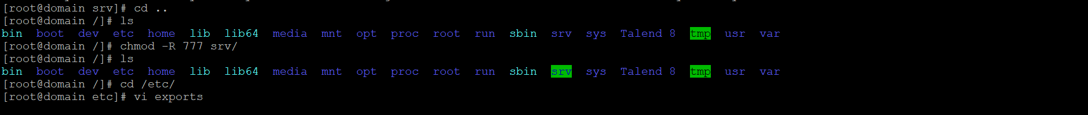vi exports

/srv 192.168.1.47(rw,sync,no_root_squash,no_subtree_check)

#restart the nfs service

systemctl restart nfs-server.service

systemctl status nfs-server.service

*Login to the 192.168.1.47 ( server 2)

#Install and start the nfs using the command

yum install nfs-utils

systemctl start nfs-server.service

systemctl enable nfs-server.service

systemctl status nfs-server.service

#mount the /srv path

mount 192.168.1.179:/srv /srv

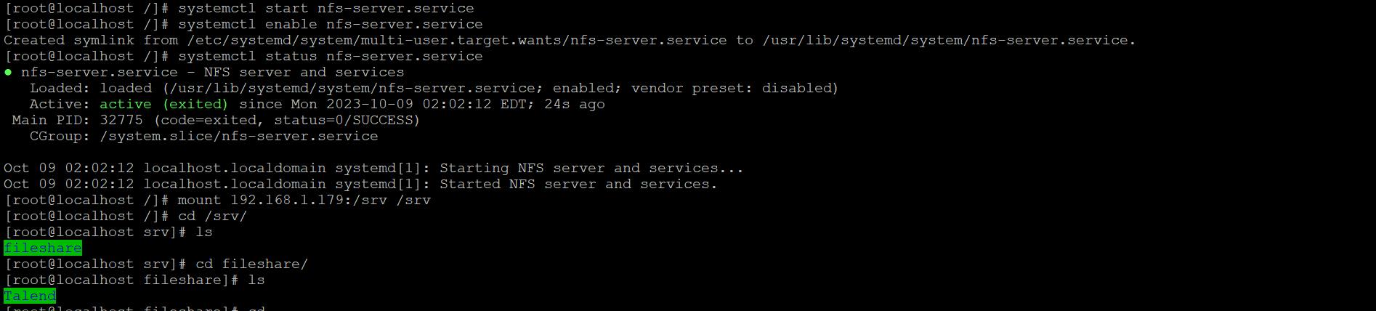

*Setup nfs on Ubuntu

<https://www.digitalocean.com/community/tutorials/how-to-set-up-an-nfs-mount-on-ubuntu-20-04>

*Setup nfs on centos

<https://utho.com/docs/tutorial/how-to-setup-nfs-server/>

Step 2:- Install TAC and jobserver on 192.168.1.47 ( Server2 ) with the same nexus configuration

*Add the same database credentials in the configuration

*login with the same user.

*Add the same configuration files.

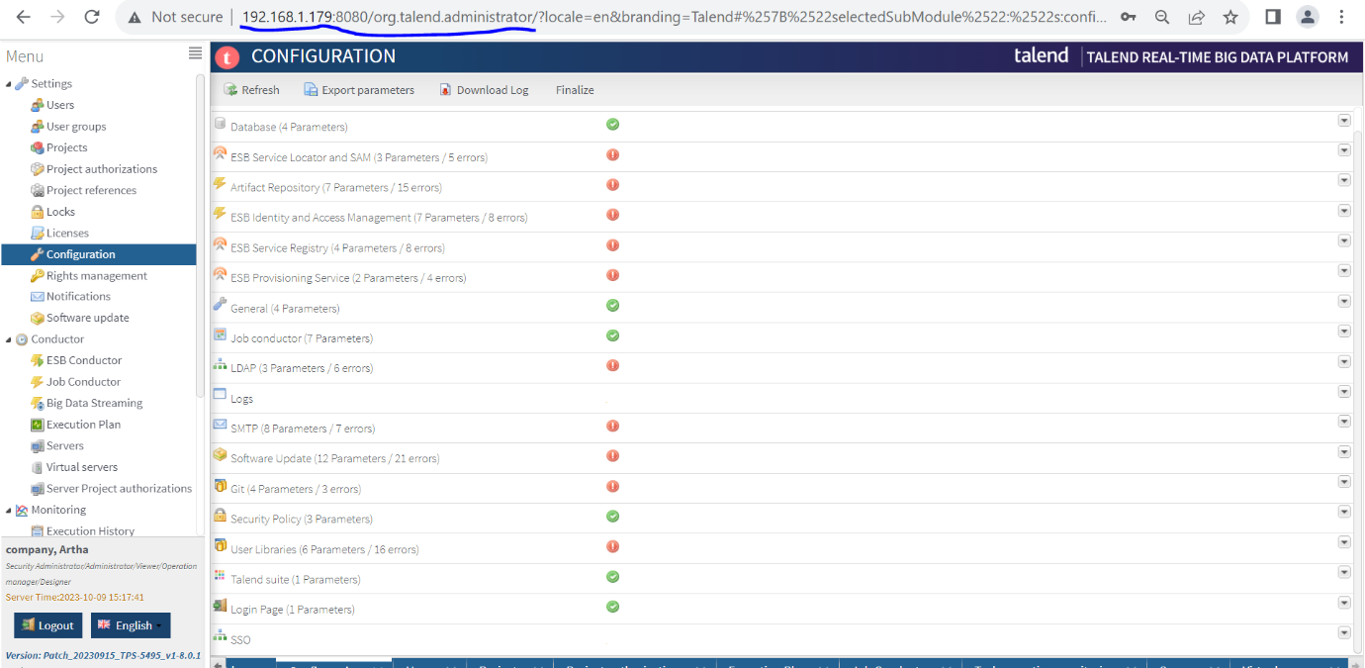

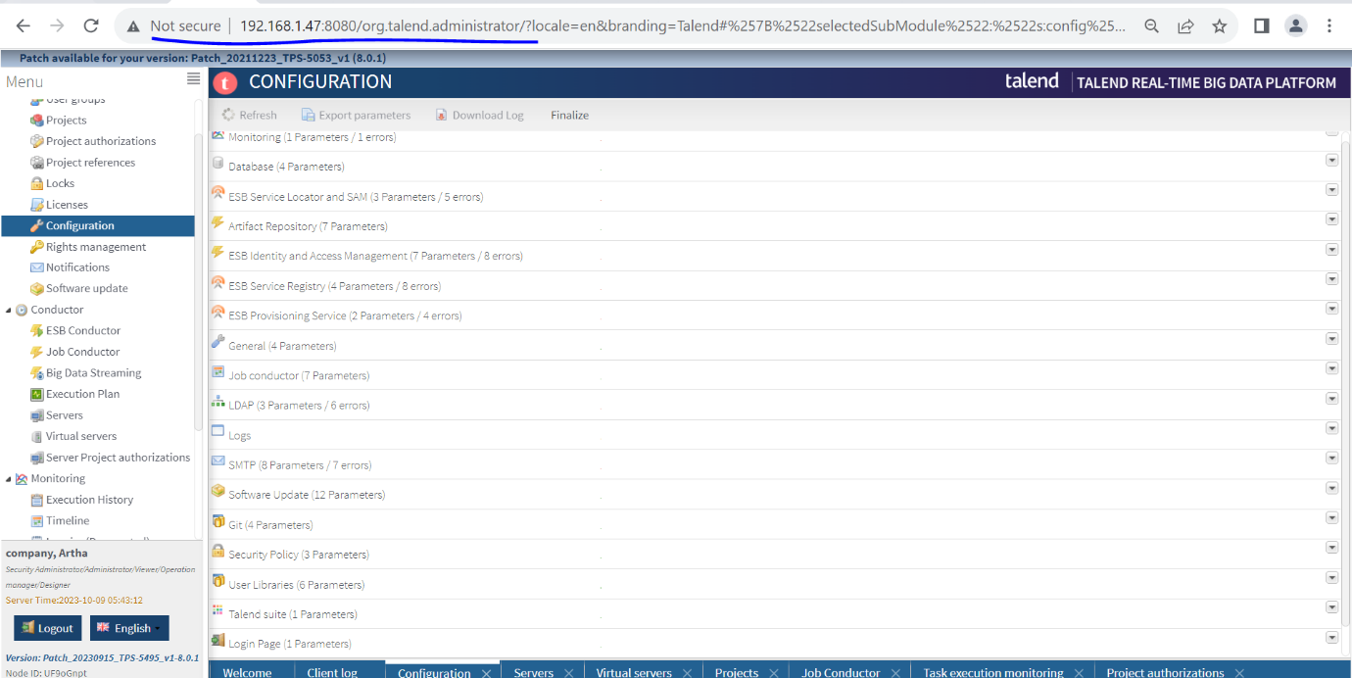

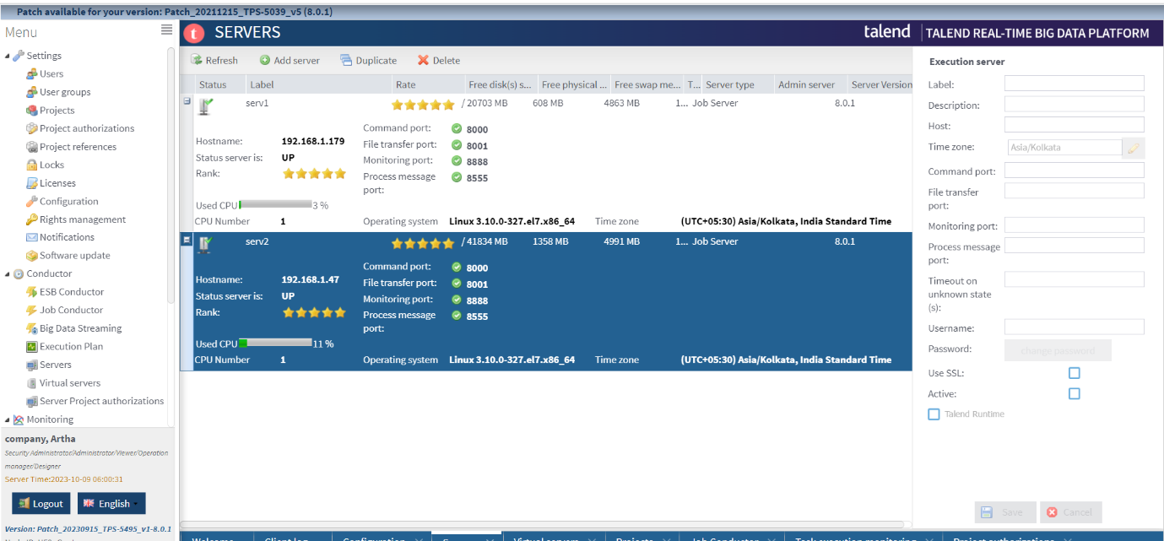

*Create a virtual server and Drag and drop the both added job servers to virtual servers.

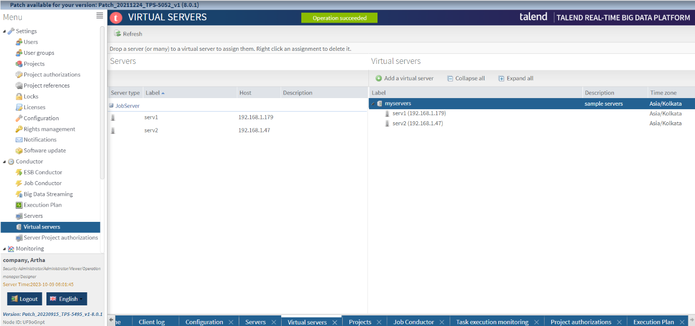

*In the job conductor add the virtual server to run the with jobserver high availability.

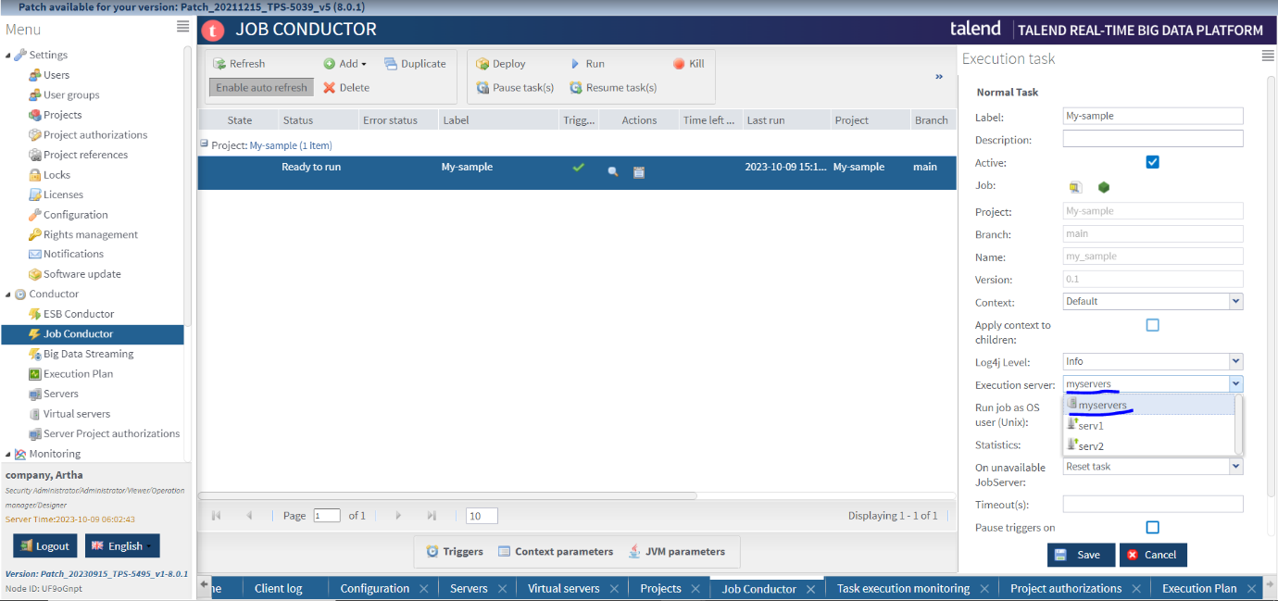

*When we run the job the job should be running parallel on both the TAC servers.

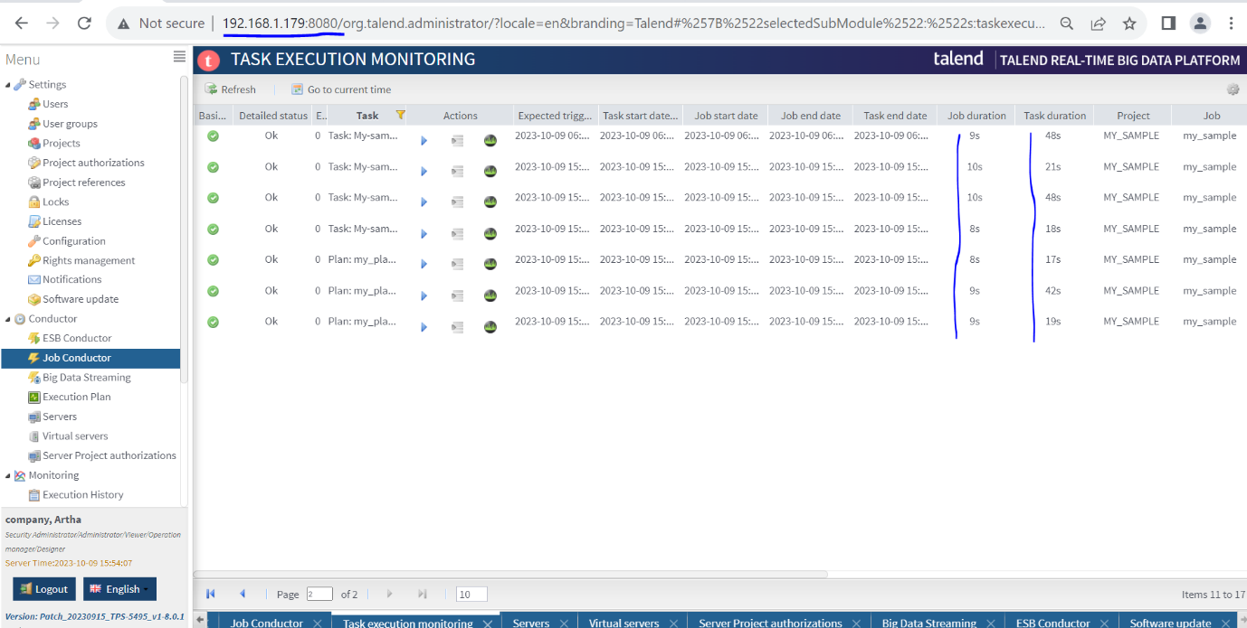

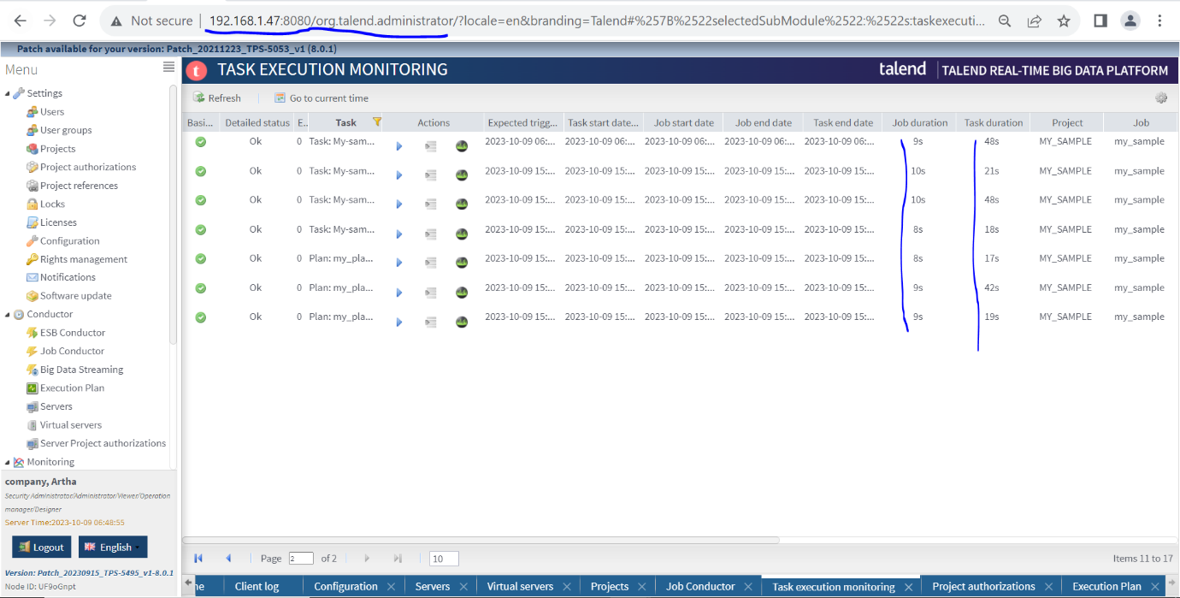

Both the servers have same execution timings both the TAC servers are working as Active Active configuration.